Algorithm Analysis

Exercises 1:
Determine Θ for the following code fragment in the average case. Assume that all variables are of type "int".
sum = 0;
for (i = 1; i ≤ n; i *= 2)
for (j = 1; j ≤ n; j++)
sum++;

Solution: Θ(nlogn)
Exercise 2:
- Give an analysis of the running time (Big-Oh notation) for each of the following 4 program fragments. Note that the running time corresponds here to the number of times the operation sum++ is executed. sqrt is the function that returns the square root of a given number.
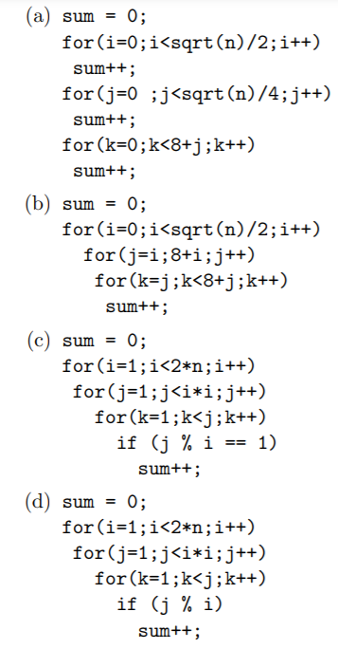
- If it takes 10ms to run program (b) for n=100, how long will it take to run for n=400 ?
- If it takes 10ms to run program (a) for n=100, how large a problem can be solved in 40ms ?
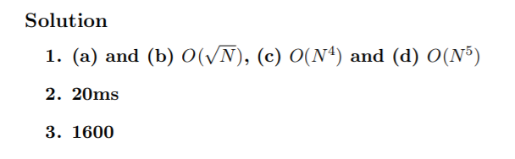
Exercise 3:
Find the complexity of the below program:
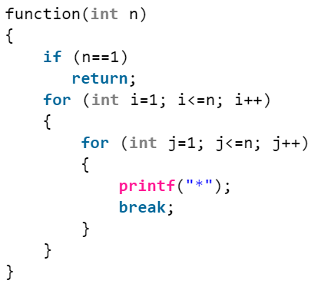
Solution: Time Complexity of the above function O(n). Even though the inner loop is bounded by n, but due to the break statement, it is executing only once.

Exercise 4:
Find the complexity of the below program:
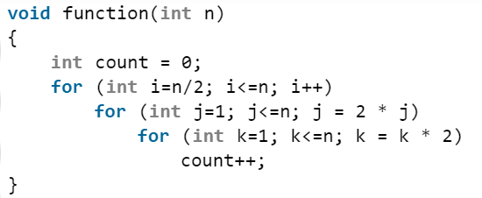
Solution: Time Complexity of the above function O(n log²n).
Explanation:
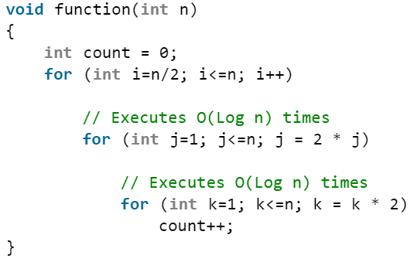

Exercise 5:
Find the complexity of the below program:
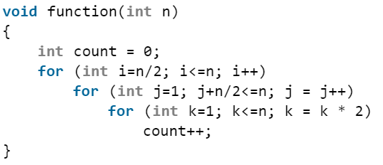
Solution: Time Complexity of the above function O(n²logn).
Explanation:
